Title (Times New Roman, 14 points, bold)
Example: This is a Properly Formatted Abstract Title

Kazuhiko ISHIHARA^{1,2}
¹Department of Materials Engineering, School of Engineering, The University of Tokyo
²Department of Bioengineering, School of Engineering, The University of Tokyo
7-3-1, Hongo, Bunkyo-ku, Tokyo 113-8656, Japan
E-mail: ishihara@mpc.t.u-tokyo.ac.jp

Title: The title should be brief, clearly indicating the nature of the presentation. When entering your title, use mixed case (do not use all caps) and do not put a period at the end of the title.

Content should be organized as follows
- Statement of purpose
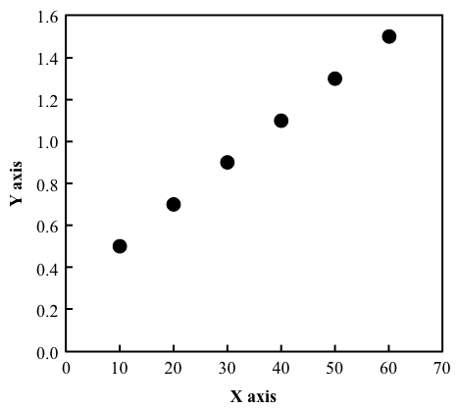
Fig. XX Figure caption
(Centered, Times new roman, 9 point)
- Methods, materials and analytical procedures used
- Summary of the results in sufficient detail to support conclusion
- Conclusions reached (do not state "results will be discussed")
- References to published literature
Text (Times New Roman, 11 point)
Abstracts are limited to one page of text.
Paper Size: Prepare your paper in full-size format on A4 size paper (210 mm x 297 mm).
The font type sizes are given in points, same as in the MS Word font size points. Arial is the preferred font.
Paper Margins: Paper margins on the A4 size paper are set as follows: top = 25.4 mm, bottom = 25.4 mm, side = 25.4 mm.
References
[1] H. Oda, T. Konno, and K. Ishihara, Biomaterials, 34(24), 5891-5896 (2013)

Important Dates:
Final abstract submission: September 20th
Please send your abstract by e-mail to nanomedicine.ibb@tmd.ac.jp

