【所属】歯周病学分野
【氏名】山田 梓
【スケジュール】
10月12日 成田発、サンフランシスコ着
10月13日 USCF school of Dentistry Research and Clinical excellence Day 2011参加
ポスター発表
免疫学教室研究室見学
10月14日 UCSF歯周病科にて口演
Mark Ryder先生のご案内により病院およびMission Bayキャンパス見学
10月15日 サンフランシスコ発
10月16日 成田着

【参加による成果】
2011年10月13日に開催されたUCSF Research and Clinical Excellence Dayに参加したためこれを報告する。
Research Day当日は午前7時30分にMark Ryder先生のオフィスを訪問し、ポスター設営を手伝っていただいた。その後8時よりCole Hallで受付およびBreakfastが用意されており、コーヒーやマフィンを片手に参加者が談笑する姿が印象的だった。9時よりオープニングセレモニーが開始され、とても和やかな雰囲気の中George Taylor先生の糖尿病と歯周病の関連および疫学調査に関する御講演があった。私は歯周病学分野所属であり、これまでの研究内容や最新の研究報告はとても興味深いものであった。またPogrel先生の講演では歯科医師として臨床だけでなく研究を行う重要性を説かれ、「なぜUCSFに患者が集まるか？それは最新の知識に基づいた最高の治療を受けられると患者が信じているからだ。」という言葉が非常に心に染みた。3名のOral presentationが行われた後、体育館に移動しポスター発表が行われた。ポスターは全部で約50本あり、私たちも場所をいただいて発表することができた。ポスター発表時はランチボックスが全員に配布されサンドイッチを食べながら各自ポスターを周るというもので、会場は肩がぶつかりあうほどの大盛況だった。様々な分野から発表がされており、積極的にディスカッションする姿があちこちで見受けられた。私も研究しているWntシグナルと骨新生に関する発表もあり、大変参考になった。また、会場では現在UCSFで勤務されている神村先生および歯周病学分野出身の山田さやか先生とお会いすることができ、UCSFでの研究生活の様子などについてお伺いし大変参考になった。
翌14日はMark Ryder先生、Armitage先生の教室にお邪魔し、大学院生15名程度の前で研究内容についてOral Presentationを行った。拙い英語でのプレゼンでかなり不安だったが、Armitage先生をはじめ皆様やさしく非常に熱心に聞いてくださり、いくつか質問や提案をいただけた。このプレゼンで自分の英会話の不十分さや、質問に英語で答えることの難しさを感じ今後より勉強しなければと痛感させられた。
ミーティングの後、UCSF Mission Bay campusに移動し、研究所を見学した。Mission Bayは広々としたキャンパスの中に研究所やスポーツジムなどが点在し、とても充実した環境であった。研究所内部は実験室間にキッチンスペースやミーティングスペースが配置され、研究者同士が交流したり意見交換しやすいように工夫されている点が興味深かった。
Research Dayに参加し、UCSFの活発な雰囲気に感銘を受けるとともに、日本の高い研究レベルやアメリカとは異なった研究環境の良さも実感することができた。今回の経験を基に、より積極的に研究活動に取り組みたいと思う。
最後にこのような機会を与えてくださった野田先生ならびにGCOE関係者の皆様、Mark Ryder先生および教室の皆様に心より感謝申し上げます。

The UCSF School of Dentistry Research and Clinical Excellence Day was held at main campus of UCSF School of Dentistry, University of California in San Francisco on the 13th of October 2011. I participated in the event by the GCOE support. Dr. Shameem Saadat also attended in the research day.
On the day, many people including undergraduates, PhD students, and teachers gathered in UCSF Medical Science building, and then welcome and opening remarks was started. Subsequently, the Keynote Speaker, Prof. George Taylor from UCSF gave us a lecture on relationship between periodontal disease and diabetes epidemic. The students were very earnest and interactive during questions and discussion. The others speakers such as Prof. Pogrel also gave us a wonderful talk about the importance of basic research.
The poster presentation was held at 11:45-13:45 at the gymnasium. Many people browsed through posters over lunch. Poster presentation discussion was very fruitful for me and I acquired nice advice and comments which will serve greatly in my future research advancement. In the Gym, we could meet Drs. Kamimura and Yamada who belong to UCSF. They taught us the difference between USA and Japan in research field.
The following day in 14th October, I really had a great chance to make an oral presentation for Prof. Ryder’s laboratory member as a title, “Expression of WNT related genes during osteogenic differentiation in human periodontal ligament cells.” Prof, Ryder’s group has about 20 students who are graduate students. They were very kindly and I’ve got some questions. Unfortunately I couldn’t answer questions well in English, and I was keenly aware of the need to study more English.
Then, Prof. Ryder took us to UCSF Mission Bay campus and we got chance to visit labs.
I was surprised that there are plenty of spaces for interaction among researchers.
Through the research day of this time, I was struck by positive atmosphere in UCSF and I rediscovered that my working environment in Tokyo was also favored.
Finally, I would like to express my gratitude to Professor Ryder, who was an excellent host during our trip to San Francisco, Professor Noda, Professor Morita and all TMDU and GCOE staffs for providing us this excellence exchange program.

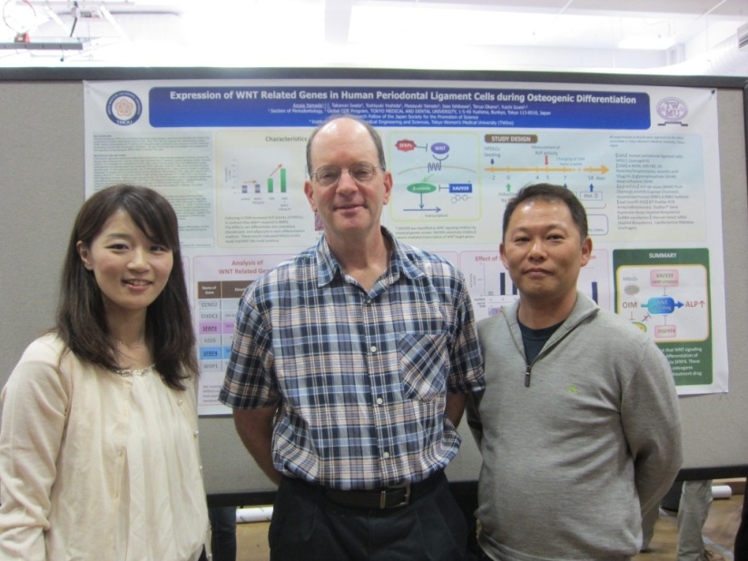
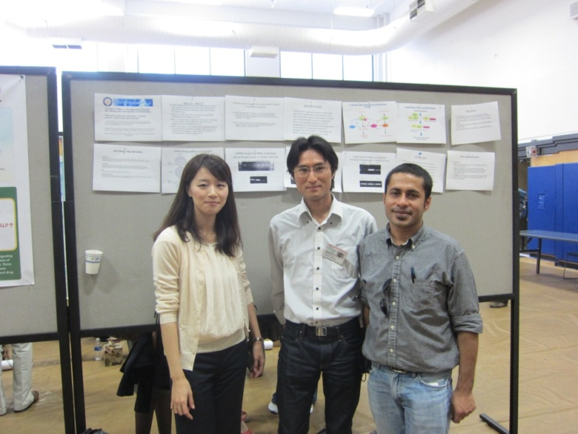
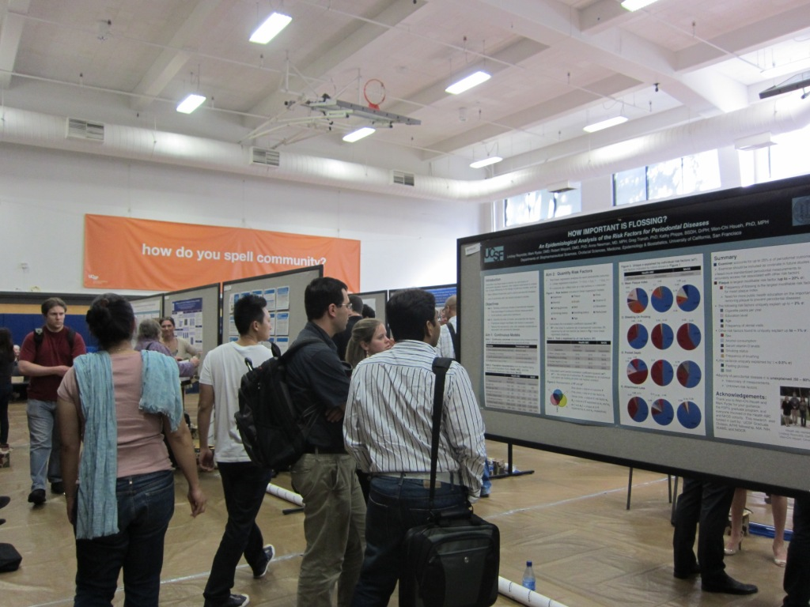
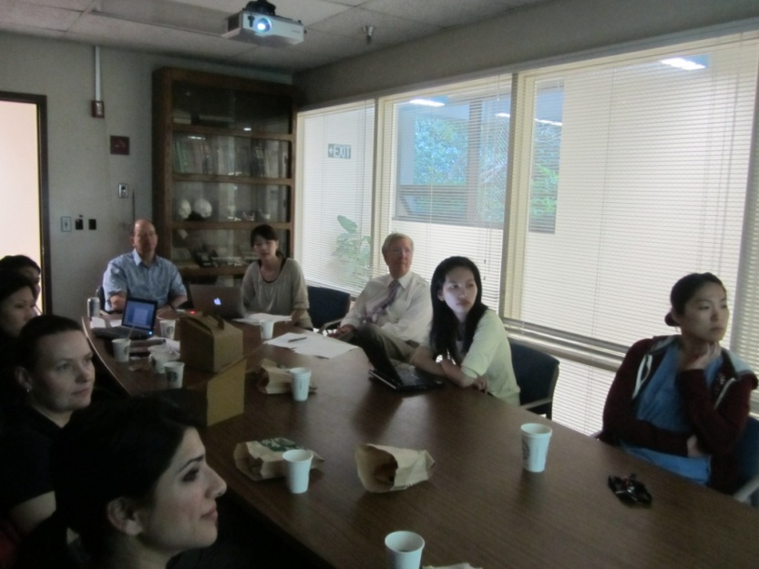
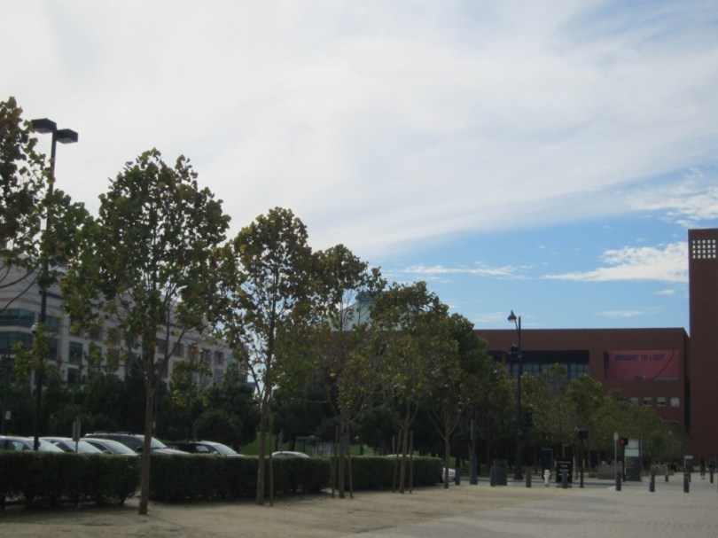

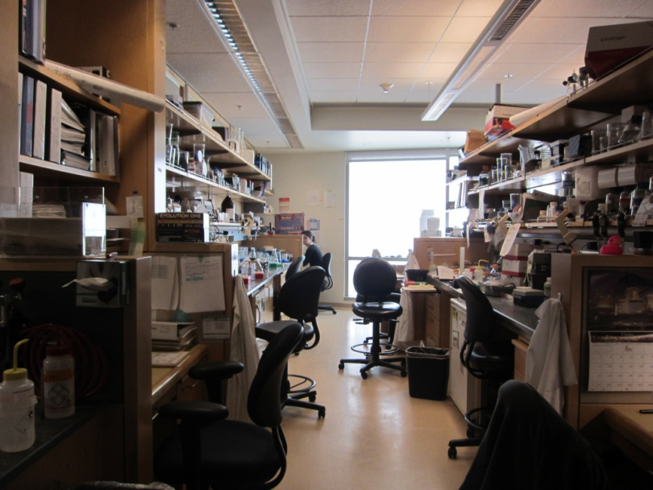

UCSF Research and Clinical Excellence Day 2011
October 13, 2011.

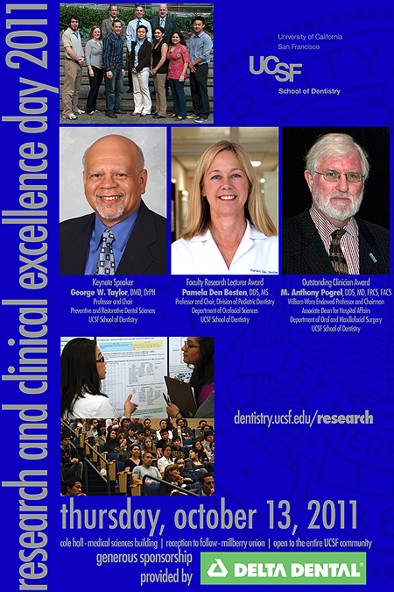

October 24, 2011
Khandakar Abu Shameem Md. Saadat
PhD Candidate
Section of Molecular Craniofacial Embryology
Graduate School of Medical and Dental Sciences,
Global center of Excellence (GCOE)
Tokyo Medical and Dental University

The University of California (UC) is a public university system in the U.S. state of California. The University of California has a combined student body of more than 191,000 students and over 1,340,000 living alumni.
Its first campus, UC Berkeley, was founded in 1868, while its tenth and newest campus, UC Merced, opened for classes in fall 2005. Nine campuses enroll both undergraduate and graduate students; one campus, UCSF (University of California, San Francisco), enrolls only graduate and professional students in the medical and health sciences.
The University of California, San Francisco (UCSF) is one of the world's leading centers of health sciences research, patient care, and education. UCSF medical, pharmacy, dentistry, nursing, and graduate schools are among the top health science professional schools in the world. The UCSF Medical Center is consistently ranked among the top 10 hospitals in the United States by U.S. News & World Report. Founded in 1873, the mission of UCSF is to serve as a "public university dedicated to saving lives and improving health."
UCSF operates four major campus sites within the city of San Francisco and Parnassus serves as the main campus. The Schools of Dentistry, Medicine, Nursing, and Pharmacy and the Biomedical Sciences graduate program are located at Parnassus.
The School of Dentistry, UCSF in 2007 ranked first among all dental schools in NIH research funding. It received awards totaling $18.3 million from the NIH. In 2011, the School of Dentistry ranked first again in NIH research funding, this time receiving $19.5 million.
In recent years UCSF is increasing the collaborations with other world famous universities.
In the UCSF Research and Clinical Excellence Day 2011 at October 13,2011, me and Dr.A.Yamada from the Dept. of Periodontology participated as the representatives of Tokyo Medical and Dental University (TMDU), collaborated, supported and promoted by Global Center of Excellence(GCOE),TMDU.
The Research and Clinical Excellence Day was held on 13th of October in the Parnassus campus of UCSF. It was the day where the undergraduate, graduate students ,post doctoral fellows and faculty members of UCSF had there competition both in oral and poster based presentation, occurred once a year to show their excellence in both research and clinical oriented fields.
The aim of the research day is to promote and advise both undergraduate and post graduate dental students on research. There was no other clinical activity or class on research day, in order to encourage the staffs and students to join the research day activity. Undergraduate students are also required to attend the lecture for their curriculum credits. The research day lectures were given by both well-known professors and some outstanding students’ research presentation and the poster presentation of students in both under and post graduate section.
The lectures were given in the Cole Hall auditorium. The keynote speaker Prof. George Tylor gave us a lecture on relationship between periodontal disease and diabetes epidemic, Prof. Anthony Pogrel about basic research and Prof. Pamela K. Den Besten gave an excellent talk about research in dental profession on both clinical and research aspects. The students were very enthusiastic and interactive during questions and discussion. We were introduced to the Vice Chancellor, Dean of the Faculty, the Chairman of Research programs, faculty members, students and other corresponding staffs at Cole hall.
The event was from 9.00 am to 5.00 pm at 13 October, composed of two sessions of lectures and one poster session.
The poster presentations started from 11.45 am to 1.45 pm at Millberry Union Gym. The poster session was warmly visited by professors, staffs and students. I am honored to do a poster presentation as an inviting/visiting pre-doctoral poster section among the two selected Global COE students from Tokyo Medical and Dental University. My poster presentation received warm attention from both students and professors. I acquired some interesting discussion and comment from person who worked in the related field of my study, which will surely contribute to my going on experiment and writing my dissertation thesis. We met with Dr. Kamimura and Dr.Yamada from TMDU, now belongs to UCSF, taught us the differences between Japan and USA.
At October 14,2011, we had a meeting in the Dept. of Periodontology with faculty members and students. Dr. Yamada from TMDU did a nice oral presentation in that meeting. Professor Mark Ryder kindly showed us the dental hospital, different research laboratories and other faculty facilities in the Parnassus campus of UCSF.
Prof. M. Ryder also showed us UCSF's Mission Bay Campus, is the largest ongoing biomedical construction project in the world. Mission Bay campus, opened in 2003 with construction still ongoing, contains additional research space and facilities to foster biotechnology,translational research,specialised hospital and life sciences. The headquarters of the new California Institute for Regenerative Medicine are also located nearby in the Mission Bay neighborhood. The J. David Gladstone Institutes, a private biomedical research entity that has recently moved to a new building adjacent to UCSF's Mission Bay campus.
There are more scopes for researchers to interact among themselves in USA. But many labs share same equipments,on the other hand we can see in Japan that every laboratory is independent for their eqiupments,what helps their students to progress their research faster.
At October 15,2011, I went to the UCSF Parnassus Campus to participate a library tour. The Parnassus Campus Library tour began at the Service Desk, 3rd floor. A staff member took us through the building, described library resources and services, introduced the library website and accounts, and answered questions.
I would like to express my gratitude to Professor Ryder, who was an excellent host during the trip at San Francisco. Professor Noda, Professor Morita, and all TMDU and GCOE staffs for providing us this excellence exchange program. I believe that this exchanging program will definitely encourage both UCSF and TMDU students in pursuing both research and clinical careers.
Sincerely and Respectfully.

