Report on,
Harvard School of Dental Medicine, Student Research Day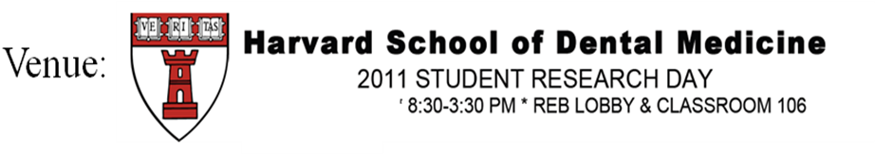
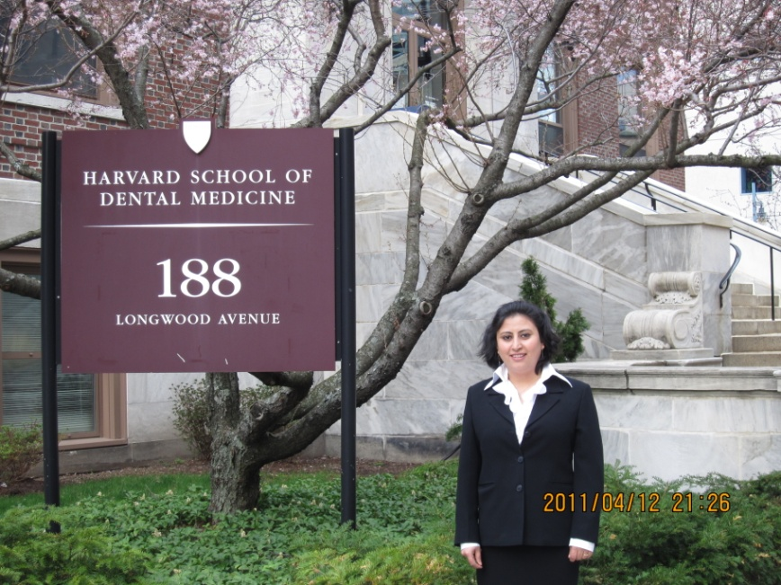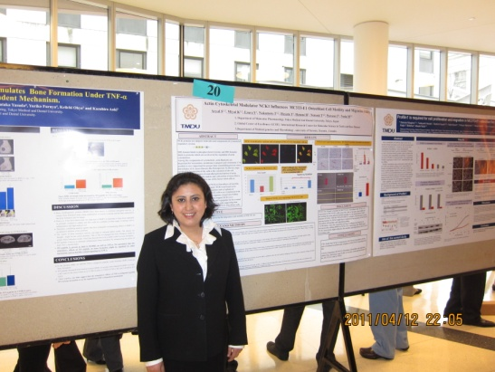
Smriti Aryal A.C
3rd year Graduate student
AISS, Global Center of Excellence Program
Department of Molecular Pharmacology
Harvard student research day was held on April 12th 2011 at Reb lobby of Harvard School of Dental Medicine, Boston, USA. This year 67 students participated in the research day. From Tokyo Medical and Dental University three students were selected to attend the research day. I feel very fortunate and pleased to get an opportunity to be one among them. During that time the participants from different research fields presented their research. Some of them presented about clinical research and some about basic science research. Each of them was very interesting in their own fields. I also had the chance to present my research that I am doing here in my Department of Molecular Pharmacology. At the time of my poster presentation session I was able to acquire an opportunity to discuss about my research with other participants and professors, among the persons that I discussed some were related to my field and some were not related to my field. Some of the professors with whom I had the chance to discuss were very famous like Professor Bjorn R. Olsen who is the Dean for research and professor of Developmental Biology as well as Professor Vicki Rosen who is very renowned specially in the bone biology field. My discussion with Professor Vicki Rosen was really very informative. I still remember when I discussed with her, she pointed out the things that I had never thought of and the experiments that I need to focus in the future. I feel very lucky about it. Then in the afternoon session we attended a lecture titled “Brain mechanism supporting the construction of sensory aspects of pain” by Robert C. Coghill from wake forest school of medicine. Although the lecture was relatively different from my field but the presentation he made helped me to know how meditation (by just concentrating on number of breaths during breathing) for about 30 minutes, 4 days can help to reduce the regions in the brain associated with pain intensity. After the lecture under the guidance of Dr. Wanida who is student of Harvard School of Dental Medicine we had an opportunity to have a short visit to the research laboratories of Professor Vicki Rosen, Professor Roland Baron and the clinics of the Harvard School of Dental Medicine. I could not find distinguishable differences between the laboratories and the clinics there with that of Tokyo Medical and Dental University but one thing I really admired there was their idea about the problem based learning system specially for that purpose there was a problems related discussion room, where the students had the contingency to discuss their problems during their studies and research which could help them to overcome their problems.
The second day 13th April 2011 we had an opportunity to join the department meeting of Professor Roland Baron. I was surprised to see that the students there were about 90 % foreigners and mainly Asians and among them major portion were post doctoral students. During the lab meeting students from that department presented their research. I really liked the way the students discussed after the presentation by precisely pointing out the things that was not clear in the presenter’s research and the presenter (researcher) should have done to clarify it. The other things that I noticed there was that all the students there worked on their projects independently which helped them to use their brains, create their own ideas and make their decisions, I think that is a key point to become a good researcher. After the meeting we had a short conversation with Dr. Saito (ex –super student of Tokyo Medical and Dental University, GCOE program) about the difference between the education system specially the research in Harvard University and TMDU. The main difference was whenever they start their project they make an experimental design, plan and that plan they discuss not only with their main professor but with the other professors in the University who are related to their work. This system is similar with the borderless system that we have now started in Tokyo Medical and Dental University and I really appreciate that system.
After the visit to Professor Baron’s laboratory we had an opportunity to visit Department of Genetics and Complex diseases under Harvard School of Public Health, we were guided by a nice gentleman Dr. Takahisa Nakamura . The lab was really a big one since that was a Public Health department they were doing research on mechanism of common health diseases like Diabetes, Cardiovascular diseases. During the lab visit I saw some machines that we don’t have in our laboratory but they have like the Micro CT machine for scanning the whole body of the animal. A noninvasive intra-vital imaging machine and the machine to record the heat produce by the body of the animal. The other thing that surprised me and was different from TMDU was here in TMDU we have a separate radioisotope center to work with radioisotope but there within the laboratory they had the small room separated by a glass where they worked on radioisotopes.
Then we had a chance to have a short communication about the doctoral program education system in Harvard with two graduate students of Harvard school of Public Health. During my discussion the differences that I found was, here in Japan we have specific period of 4 years to complete our Doctoral course but there they don’t have that specific time . They said that the time varies according to the research and the professor if you are lucky and get the data then you can finish Doctoral course fast and if not than 5-6 years depending on the projects that the person is working on. When we had the conversation the student there gave us some idea about writing the review papers that we really don’t do during our graduate course. They said that during our research we study lot of references so we should write some review articles which would help to boost up our knowledge about our research work. I had never thought about this thing deeply. I really liked that idea and thought it was a good point to focus on to increase our publications and knowledge. The other systems were similar to those here in TMDU. This was a brief report about my visit to Harvard School of Dental Medicine although it was a short visit but the experience and achievements that I accumulate there is one of the valuable asset for my whole life. The most important thing that I gained from my visit is the inspiration and confidence from deep inner core of my heart and I would like to utilize these feelings to make it as a tool to pursue my future research work.
Finally I would like to express my special gratitude and thanks to the most important and respectful persons, Professor Masaki Noda, Professor. Ikuo Morita and the Global Center of Excellence Program (GCOE ) committee members who had given me this opportunity to experience a valuable moment in my life and also to the members of Harvard School of Dental Medicine, to let us experience such a important time in Harvard School of Dental Medicine. I would like to recommend my colleagues who are the super students in the GCOE program to apply and participate in the next research day.

Harvard Medical School Harvard University Dental School and Hospital
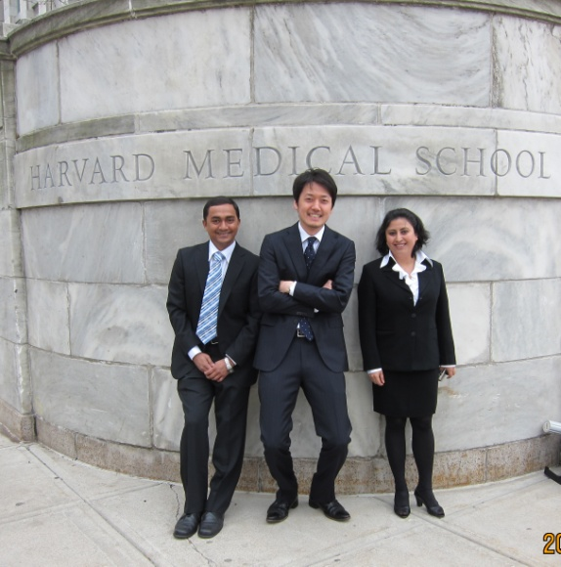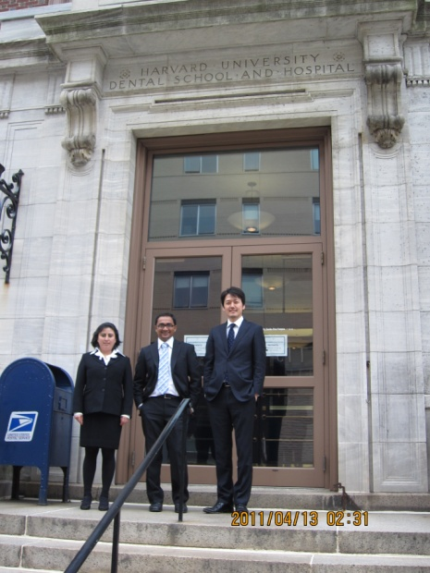
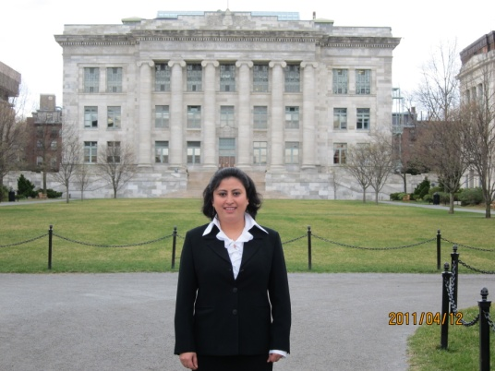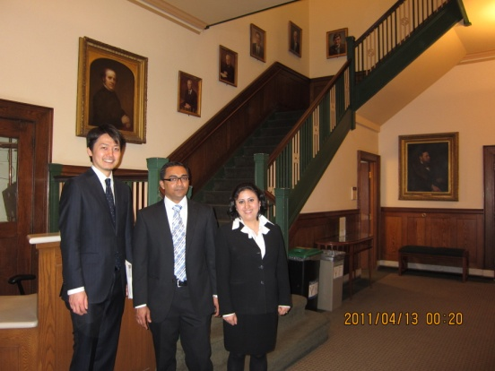
With Prof. with Professor Bjorn R. Olsen, Dean for Research and Professor of Developmental Biology
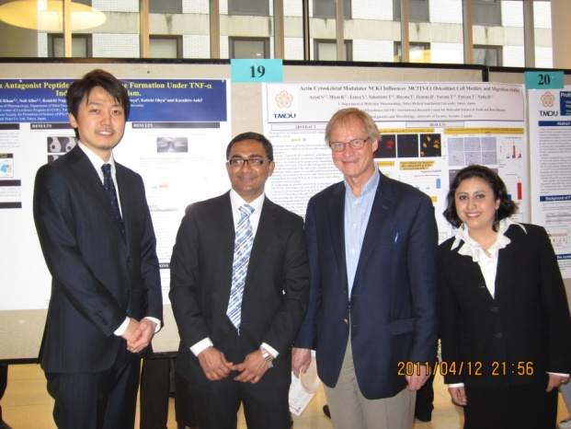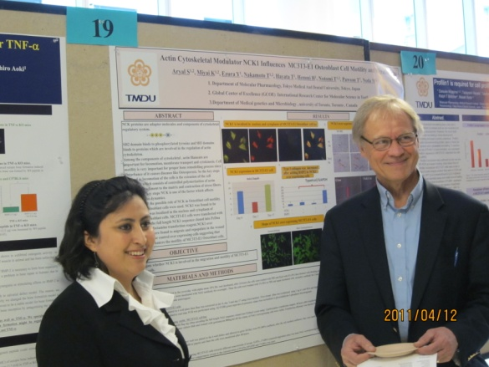

Discussion with Prof. Vicki Rosen, Department head and Professor of Developmental Biology

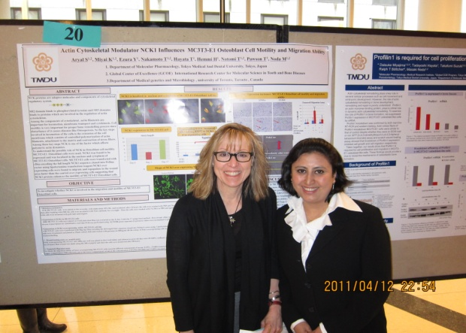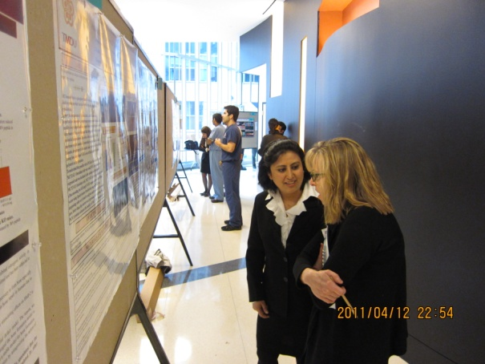

Discussion with Prof. Donald B. Giddon, Clinical Professor of Oral and Development biology
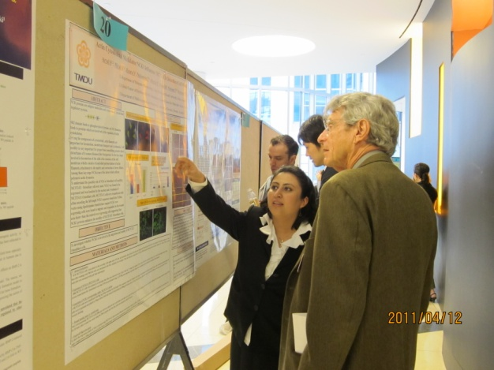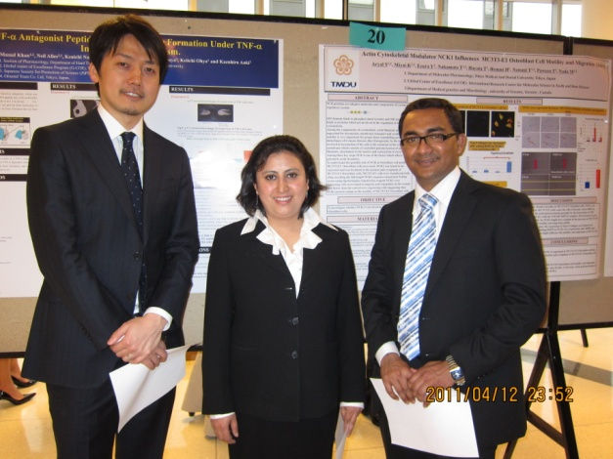

Discussion with Graduate students of Harvard School of Dental Medicine
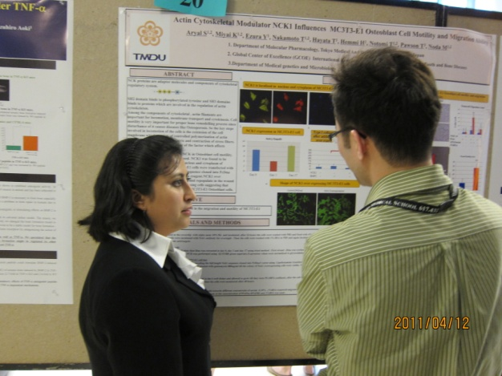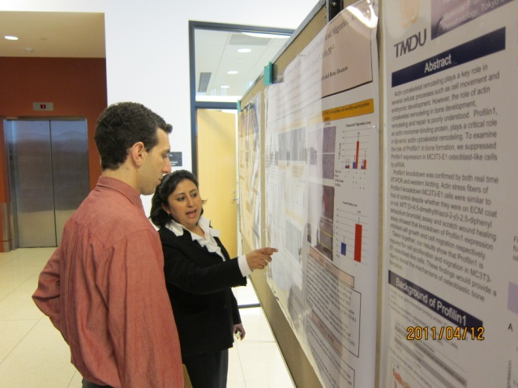

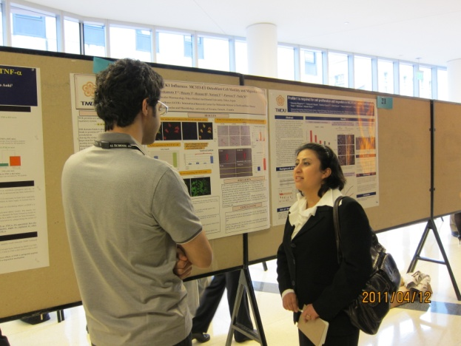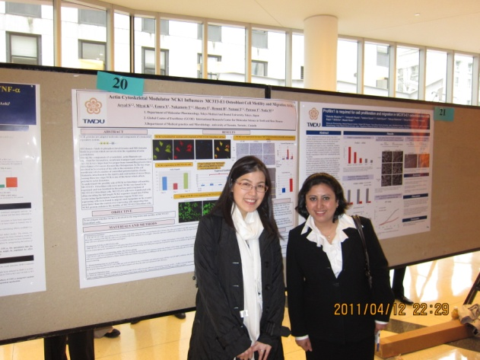
With Dr. Wanida
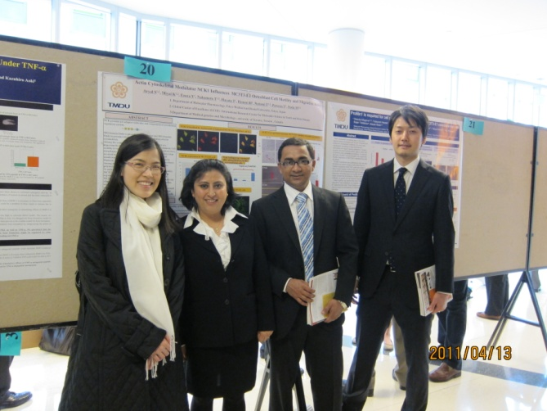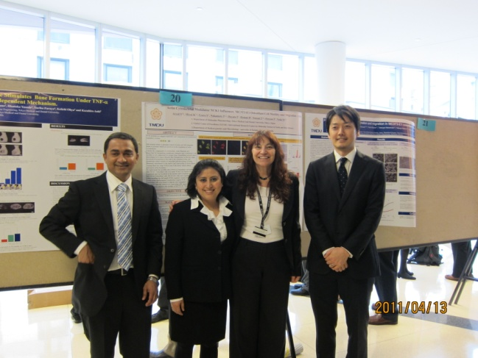

With Aliea (organizing member of Harvard Research Day)
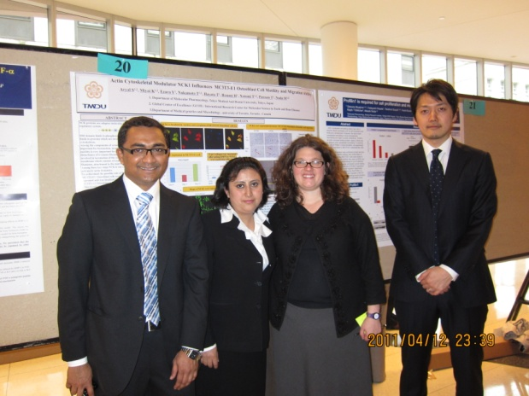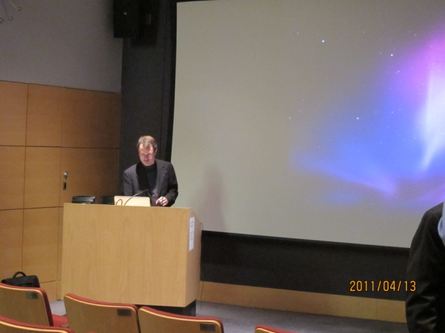
Prof. Robert C. Coghill, Wake forest School of Medicine With Dr. Ono and Dr. Saito
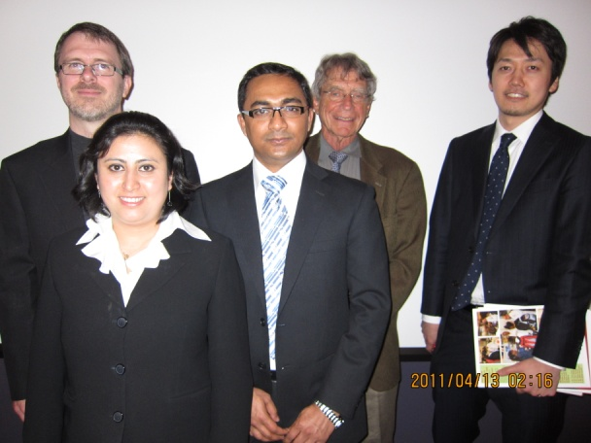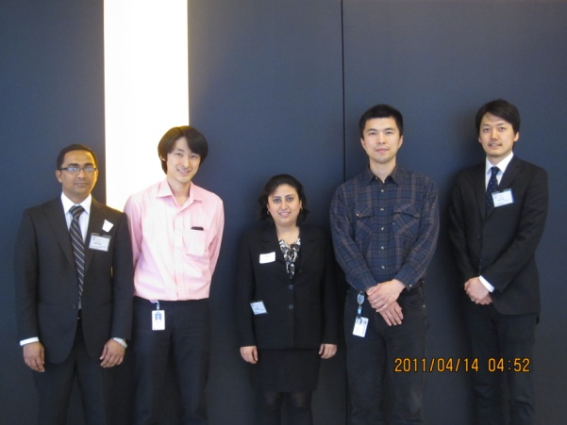

With lab members of Prof. Roland Baron
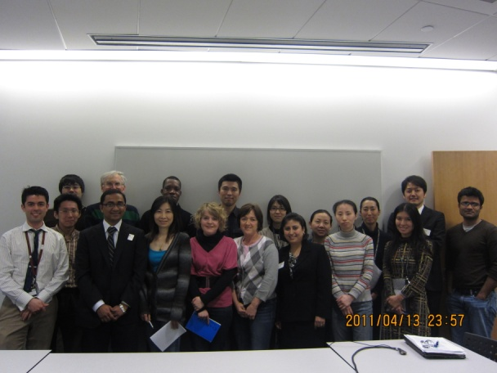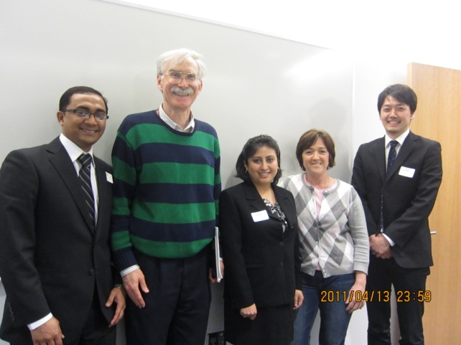

Harvard University School of Public Health
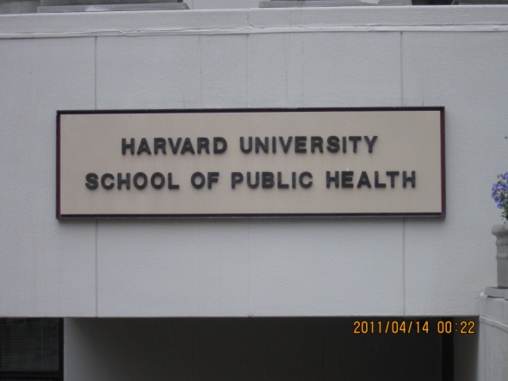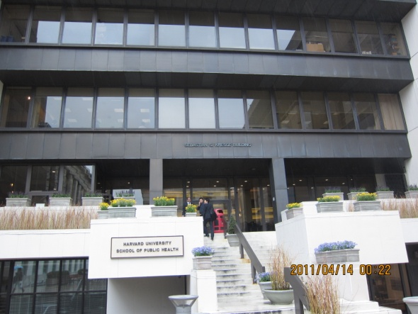

With Graduate students of Harvard school of Public Health
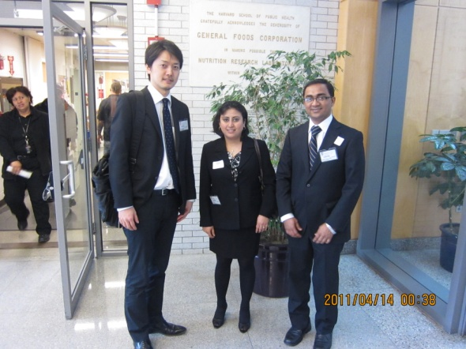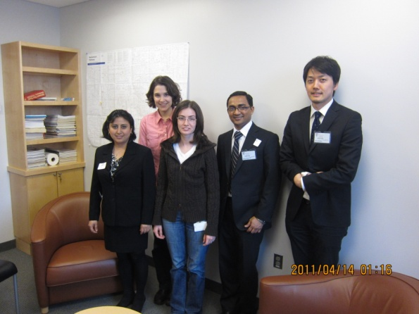

With Dr. Takahisa Nakamura (Research associate, dept of Genetics and Complex Diseases)
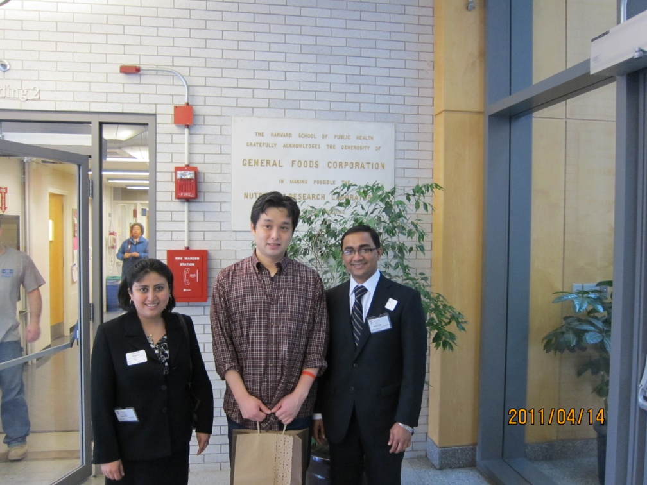
Report on
HSDM Student Research Day
April 12, 2011
MD ABDULLA AL MASUD KHAN
3rd Grade Graduate Student
Section of Pharmacology, Department of Hard Tissue Engineering
AISS, Global Center of Excellence (G-COE) Program
Each year Harvard School of Dental Medicine (HSDM) arrange a special “ Student Research Day” offering an opportunity to the students of different corner of the world as well as their own students to present their
research work on that occasion.
For this prestigious program, this year three students from Tokyo Medical and dental University were invited to attend there and it was a great honour to me to be one of them.
Research day consists of morning session and evening session. Morning session consists of poster presentation by graduate students and in the evening session, undergraduate students presented their poster.
2011 Student Research Day was held on 12th April from 8.30 am – 3.30 pm in research and Education Building lobby of the main campus.
Morning session was started at 8.45 am with welcome ceremony and introductory speech. We were received with warm reception from graduate student of Harvard School of Dental Medicine.
Our poster presentation was held during morning session from 10 am- 10.30 am together with graduate students of Harvard University.
We presented our poster and received outstanding response from others researchers. We had a useful discussion with graduate students of Harvard University. They showed their interest about our research and inquired some important points with curiosity which will be helpful for our future work. I was so pleased that renowned professor Vicky Rosen came to see our poster. It was great honour to me to have the opportunity to discuss with her about my research. She placed valuable suggestions which will be very helpful for me to make future research plan. Also I shared my research knowledge with two famous researchers, Professor Olsen and Professor Donald B. Giddon. They applauded my research work and gave
constructive suggestion.
After our poster presentation session an interesting lecture was taken place. Honourable guest speaker was Associate professor Robert C. Coghill (Dept. of Neurobiology and Anatomy, Wake Forest School of Medicine) on this part. His topic was “Brain Mechanism Supporting the Construction of Sensory Aspects of pain”. Although I am not so familiar with that topic but it was really interesting to me.
A graduate student of Harvard University assisted us to visit dental hospital after that session. That was a nice experience for us.
On the next day, we visited Professor Roland Baron’s lab and attended their journal club meeting. I had a special chance to give an oral presentation on their lab and I confidently presented my research. My presentation was praised by the audience and they gave valuable suggestion for my future work.
After that, we meet Dr. Takahisa Nakamura (research associate, dept of Genetics and Complex Disease). We visited public health department of Harvard University under his guidance. We got introduced two graduate students their and exchanging our views regarding research opportunity between two university. We completed the academic tour on that day and returned on 14th April to Japan.
The total tour in Harvard University was outstanding in context of its contents and motives. I think, the knowledge sharing experience on that prestigious institute was so courageous for a research student like me to continue my task with full inspiration and very helpful to step forward to the research work with complete dedication.
Finally I would like to show special gratitude and thanks to Professor Masaki Noda, Professor Ikuo Morita and the organizers of the program to let us have a special opportunity and to gather wonderful experience in Harvard School of dental medicine. I would like to thank also to other two students Miyajima Daisuke, Smrity Aryal A.C with whom I passed memorable time there being representative of Tokyo Medical and Dental University.
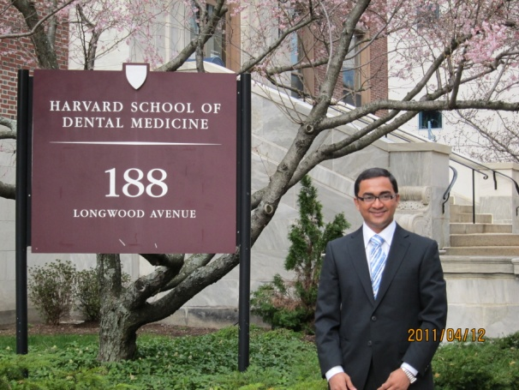
Poster presentation with Professor Vicki Rosen With Professor Olsen
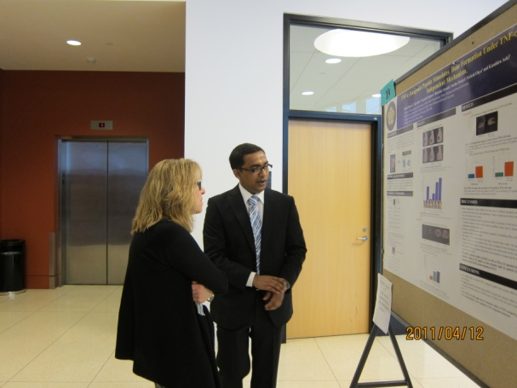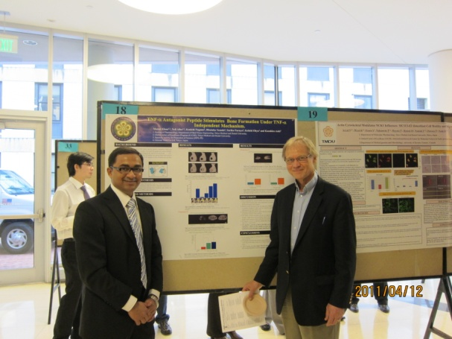
With Professor Giddon With Associate professor Coghill
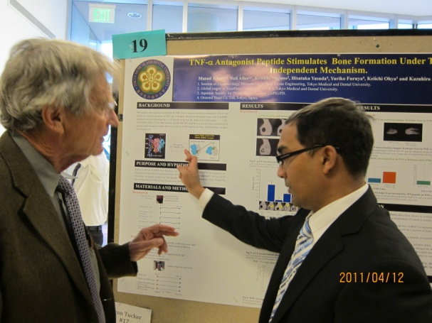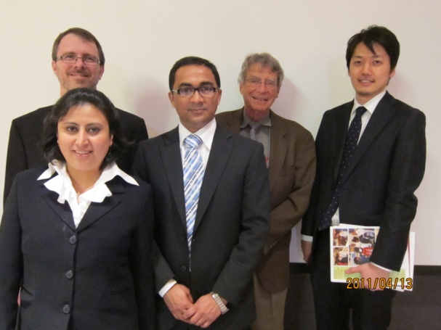
Poster presentation with post graduate student of Harvard University
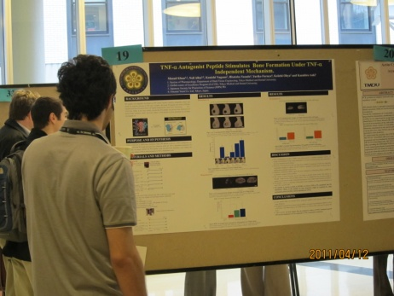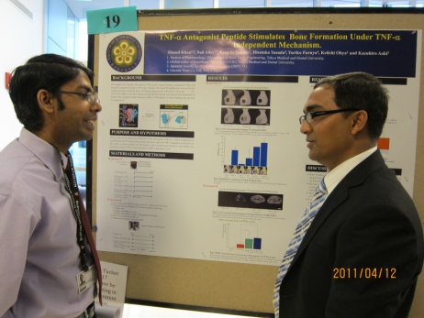
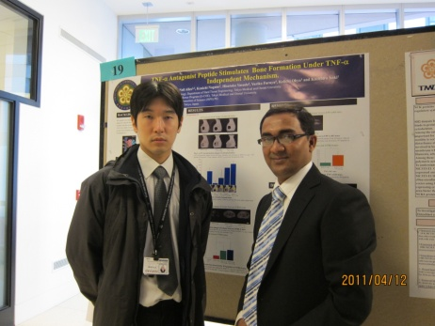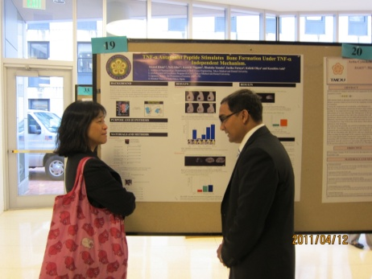
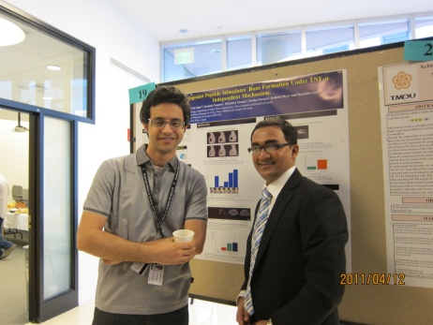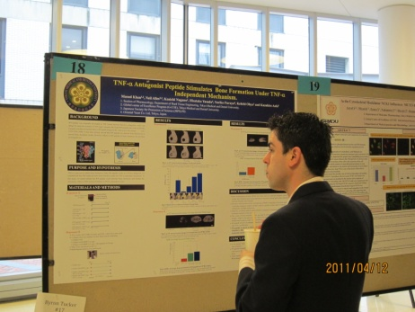
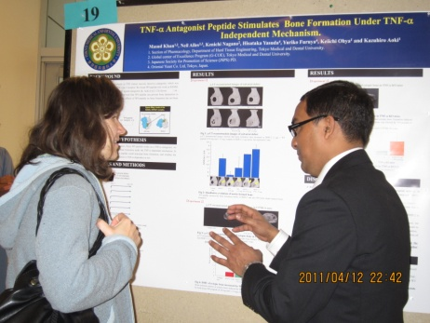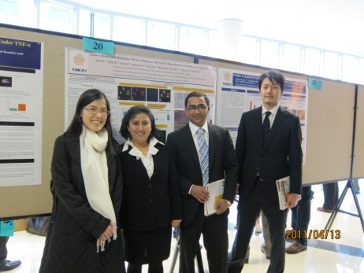
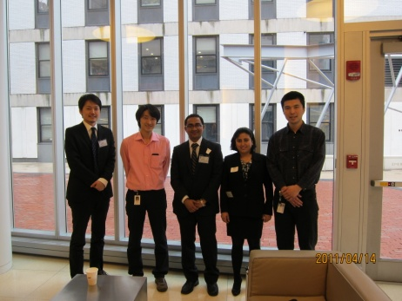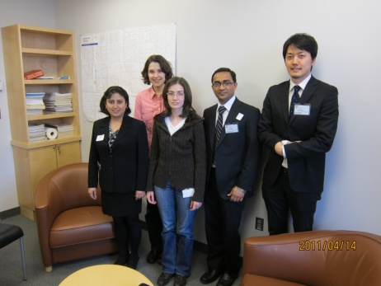
With Dr. Takahisa Nakamura Presentation at Professor Roland Baron’s Lab
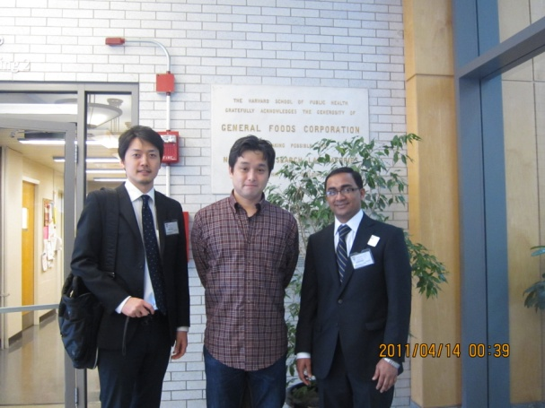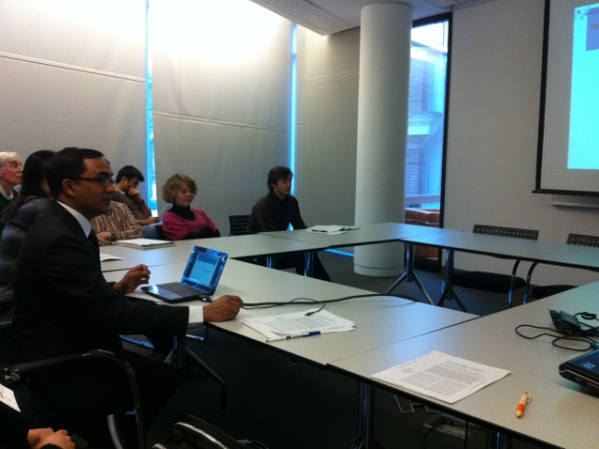
With journal club members of Professor Roland Baron’s lab
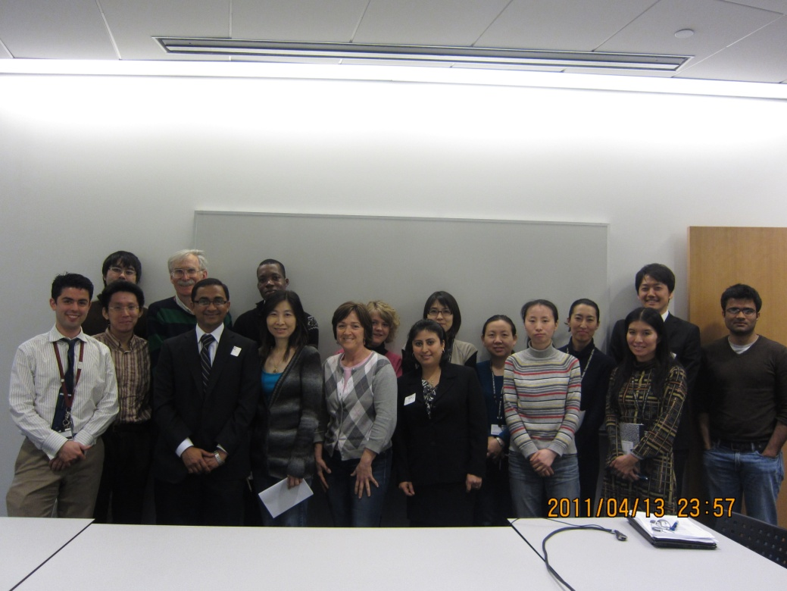

Report On
HSDM Student Research Day
April 12, 2011
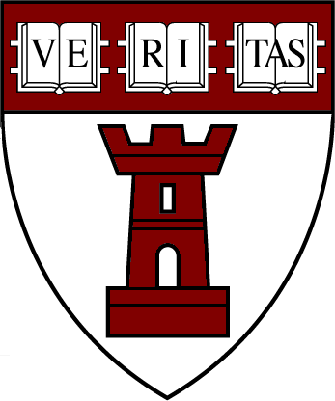

2011年ハーバード大学歯学部リサーチデーに参加して
硬組織薬理学分野 大学院4年
G-COE AISS Md. Abdulla Al Masud KHAN
平成23年4月12日

2011年4月12日に、G-COEのAISSであるMd. Abdulla Al Masud KHANはHarvard School of Dental Medicine Dayに参加した。これは、ハーバード大学が主催して年に一回行われるもので、大学内外の学部および大学院生に研究発表の場を与えるものであり、東京医科歯科大学から招待された3名の一人に選ばれたことを大変誇りに思う。
リサーチデイは、ポスター会場となったロビーで、朝8時30分から午後3時半まで行われた。我々も、午前中のポスター発表の部で自身の研究を発表した。ロビーは学生や教官で込み合っていて、みな精力的にデイスカッションを行っていた。特に、ビッキー教授と、ポスター発表した研究についてデイスカッションしたことは、今後研究をどのように進めていけばよいのかを考える上で大変有意義だった。また、オルソン教授とギドン教授からは、私の研究内容を踏まえたうえで、より建設的な提案を戴いた。
午後には、ゲストスピーカーであるコーンヒル准教授（Wake Forest 医科大学、神経生物・解剖学分野）による、講演『痛みの感覚を構築する脳のメカニズム(Brain Mechanism Supporting the Construction of Sensory Aspects of pain)』を聞いた。専門外の私にとっても本当に興味深い内容だった。その後、ハーバード大学学生が我々を連れて歯学部病院を案内してくれたのも、貴重な経験だった。
次の日は、バロン教授の研究室を訪問して、抄読会に参加し自分の研究内容について口頭発表を行った。その後、公衆衛生学分野を中村助教（遺伝性難病分野）の案内で訪問した。そこで、ハーバート大学と東京医科歯科大学との間での研究共有の機会について意見交換を行い、今回のハーバード大学滞在のプログラムを終え帰国の途についた。
全日程を振りかえってみると、リサーチデイが行われている環境と動機が特に優れていることに気がつく。このような有名な研究施設で研究動向や情報を交換した経験は、私の今後の研究生活に大きな勇気と励ましを与えてくれたと強く感じている。
最後に、今回このような機会を与えて下さった野田教授、森田教授をはじめとするG-COEの先生方、事務の方々や、現地でお世話になった先生方他に、心から感謝の気持ちでいっぱいである。また、一緒に参加したお二人にも御礼を申し上げたい。

リサーチデイ参加後レポート
所属：分子薬理学分野
- 氏名：宮嶋大輔
- スケジュール：
4月11日：東京発、ボストン着
4月12日：ハーバード大学歯学部リサーチデイに参加
4月13日：斉藤広章先生、中村能久先生、小野法明先生と会談
4月14-15日：ボストン発、東京着
- 参加による成果
和文
201１年4月12日に行われたハーバード大学歯学部リサーチデイ（研究発表会）に、東京医科歯科大学グローバルCOEプログラムの人材育成教育活動の一環として参加し、ハーバード大学の大学院生ならびに研究者との交流による教育を受ける機会を得ることができたので、この概要を報告する。グローバルCOEプログラム参加学生から、私を含め、3名が派遣され、私以外の2名は、それぞれ、硬組織薬理学分野のDr. MD. Abdulla Al Masud Khanと、私と同じ研究室である分子薬理学分野のDr. Aryal A.C Smritiであった。出生国も母国語も異なる3名が、東京医科歯科大学での研究活動を共通の背景に参加できたことは、留学生数が多い本プログラム以外では得難い機会であり、道中のすべてが楽しく良い経験となった。4月12日、リサーチデイ当日は、大学院生によるポスタープレゼンテーションが約50演題、またRobert C. Coghill先生による、痛みの脳メカニズムに関する講演が、それぞれ執り行なわれた。私自身も1時間以上もポスター発表ができ、多くの学生と研究者とディスカッションすることができた。なかでも、BMPシグナルの研究で高名なDr. Vicki Rosenと対話し、具体的なアドバイスを得ることができたことは、非常に良い機会であった。翌4月13日には、ハーバード大学で仕事をなさっている斉藤広章先生、中村能久先生、小野法明先生とそれぞれ会談し、研究施設の見学もさせて頂いた。研究内容のディスカッションの他に、ハーバード大と日本との違い、それぞれの留学の経緯、今後の目標、また私の大学院卒業後の進路について、話をすることができた。印象的だったのは、類似の研究テーマをもつ複数の研究室が合同で行うdepartment meetingなるものがハーバード大にはあり(他の大学にもあるようだが)、研究室間で最新情報が共有できるシステムがあることだった。より効率的に研究を進める上で重要なシステムだと感じた。リサーチデイから得た多くの刺激的な経験を生かし、残りの大学院研究生活をさらに充実させていきたい。最後に、このような大変素晴らしい機会を与えて下さった野田先生ならびにグローバルCOEの先生・スタッフの皆様、そしてハーバード大で大変お世話になった斉藤広章先生、中村能久先生、小野法明先生、および各教室員の皆様に、心よりお礼申し上げます。

英文
Harvard University School of Dentistry Student Research Day was held on April 12, 2011. I attended at the scientific meeting as a member of global COE program of Tokyo Medical and Dental University (TMDU) for my training and development, and I met many graduate students and famous scientists. As I had a wonderful experience through the meeting, I report briefly here what I saw and heard during my stay in Harvard.
Two global-COE students, Dr. MD. Abdulla Al Masud Khan and Dr. Aryal A.C Smriti, also partook in the research meeting. We three are from different countries and speak different mother languages. I see this encounter as a benefit in this training program, for there are a lot of foreigner students in global COE program of TMDU.
On the day of the research day, 50 poster presentations were executed by graduate students and the lecture concerning the brain mechanism of the pain was given by Dr. Robert C. Coghill. I also gave my presentation for over an hour and discussed my study with many people including a famous scientist of BMPs, Dr. Vicki Rosen. I am grateful for her advices on my examinations.
On the following day, we met three Japanese scientists, Dr. Hiroaki Saito, Dr. Takahisa Nakamura, and Dr. Ono Noriaki, respectively. They showed us their laboratories and some facilities. We talked not only about studies of each other’s, but also the differences between Harvard and Japanese laboratories, and how and why did they choose a life in Harvard. I was inspired by them very much and I got some advices about my future academic life. And what I thought a good system was “department meeting”. In the meeting, several laboratories in the same research field show and discuss their recent findings with each other. So the participants share wide-ranging hot information with each other.
Finally I express my appreciation to Prof. Noda and every GCOE staffs for giving me this wonderful opportunity to go to Harvard research day. And I have to express my thanks also to Dr. Hiroaki Saito, Dr. Takahisa Nakamura, and Dr. Ono Noriaki for their kindness.

