15th Asian Bioceramics Symposium (ABC2015)
Abstract Submission Form
E-mail: abc2015v@gmail.com

<< Presenter’s Information >>

Title: □ Dr. □ Prof. □ Mr. □ Ms. (Answer using □ or ■)

Name:

Department and Institution (Organization)

E-mail:

Address:

Telephone

Presentation Preference: (Answer using □ or ■)
□ Oral □ Poster □ Poster (Apply for the science awards for students)

Final decision on allocation will be made by the Program Committee. Your preference may subject to change in accordance with the number of submissions.
Awards are given to excellent poster presentations conducted by students in undergraduate or graduate programs, technical colleges, and junior colleges so as to increase research motivation. The application should be undergraduate or graduate student at a College or University, Student of junior college, or Student of technical college.

Proceeding submission: (Answer using □ or ■)
□ Do plan to submit, □ NOT plan to submit

Proceedings of the ABC2015 will be published in a specially-scheduled issue of Phosphorus Research Bulletin Vol. 31. All the submitted papers will be peer-reviewed.
Phosphorus Research Bulletin: https://www.jstage.jst.go.jp/browse/prb, http://www.jaipc.jp/?page_id=47

Instructions for Preparing Camera-Ready Abstracts for ABC2015 (Times, 12 points, Bold, Centered) Title should be less than 5 lines.
← This blank space is for a serial number.

First Author^{1,*}, Second Author², and Third Author^{1,2} (10 points, Times, The presenting author is specified with an asterisk *.)

1 Department of Biomaterials, Japan University of Science and Technology, City, State ZIP Country
2 Department of Materials Science, Super Global University, City, State ZIP Country

E-mail: corresponding_author@server.univ.edu (Times, 10 points)

(Abstract body: Times, 11 points) Authors should prepare one-page camera-ready abstracts using this template file. The abstracts will be printed in an Abstract Book in the same size. The abstract page should have margins of 25.4 mm for top, bottom, left, and right in the A4 size.

Abstract should clearly describe background, objective, method, and significant results and conclusions. The page length must be one page including tables and figures and the length of the abstract body is limited to 400 words [1].
The abstracts should be submitted via our web site <http://***** > in PDF format.

[1] T. Kanda, N. Ichigaya, and M. Ochanomizu, Cell adhesion rate on room-temperature superconductor ceramics, Phosphorous Res. Bull., 127, 245–249 (201x).

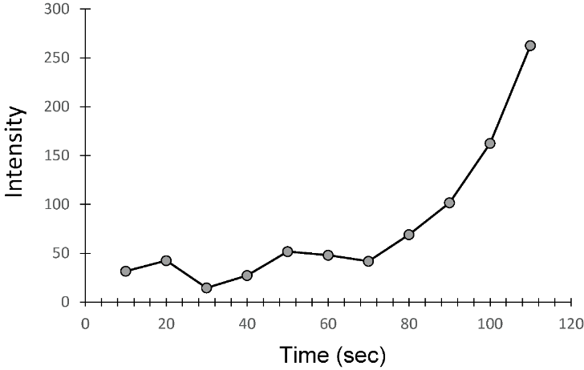
Fig. 1 Figure caption (Times, 11points)

